RIIO-2 Licensee Open Data classification and controls position paper

Author(s):
Open Energy Working Group

Document title: RIIO-2 Licensee Open Data classification and controls position paper
Document code: IB1-OE-OPENDATAPOSITIONPAPER
URL: http://ib1.org/energy/uk
Version: v2026-01-12

Contents
Introduction 2
RIIO-2, “presumed open” and the NPSA 2
Publication differences 3
SSEN-D Substation Data 3
National Grid: Distribution Substations 4
UKPN: Secondary Sites 5
SPEN LV Monitoring Aggregated Data & substation geopoints 6
Northern Power Grid Substation Sites List 7
ESTF Assured Open Data (AOD) scheme 8
Position for licensees 8
Amendment to Assured Open Data 9

Introduction
During 2025, conversations with RIIO-2 licensee members of Open Energy surfaced uncertainty about how best to comply with the “presumed open” requirement of Ofgem Data Best Practice Guidance while also having access controls on data. A draft of this position paper was circulated ahead of a licensee working group meeting held on November 26, 2025. Following input from the workshop, this updated draft is being circulated for further feedback from wider energy data stakeholders. Open Energy members hope that all RIIO-2 licensees will benefit from a clearly-articulated position on Open Data classification and access control.

RIIO-2, “presumed open” and the NPSA
The RIIO-2 licensees are required to “use Energy System Data in accordance with Data Best Practice guidance. In particular, the guidance will include the principle of Energy System Data being treated as ‘presumed open’”. By the end of 2023, all licensees had launched data portals to publish their Open Data.

In February 2024, in response to concerns from NPSA/NCSA about some asset datasets being indexed by Open Net Zero, Ofgem sent a note to RIIO-2 licensees titled “Assessing Open Data Release Security Risks”. It urged more consideration of potential threats when assessing whether to release data with an Open licence and prompted data publishers to consider extra controls where needed:
- Requiring user logins/registration/confirmation of organisation and identity
- Logging of data access and downloads by users
- Removing bulk download capabilities
- Removing embedded identifiers, names and related asset information
- Restrict map views to limited areas, or based on user need.

In response to the first two items, licensees implemented a registration requirement on their data portals. However, they have taken different approaches to registration and the data licence, even for similar datasets.

Regarding the choice of Open Data licence, para 3.33 of the Data Best Practice Guidance stipulates that “The licensee when making Open Data available to current and prospective Data Users, must do so utilising the latest version, or a subsequent iteration, of the Creative Commons Attribution Licence or the Open Government Licence.”. Not all licensees are using these licences.

Publication differences

SSEN-D Substation Data
https://data.ssen.co.uk/@ssen-distribution/ssen-substation-data

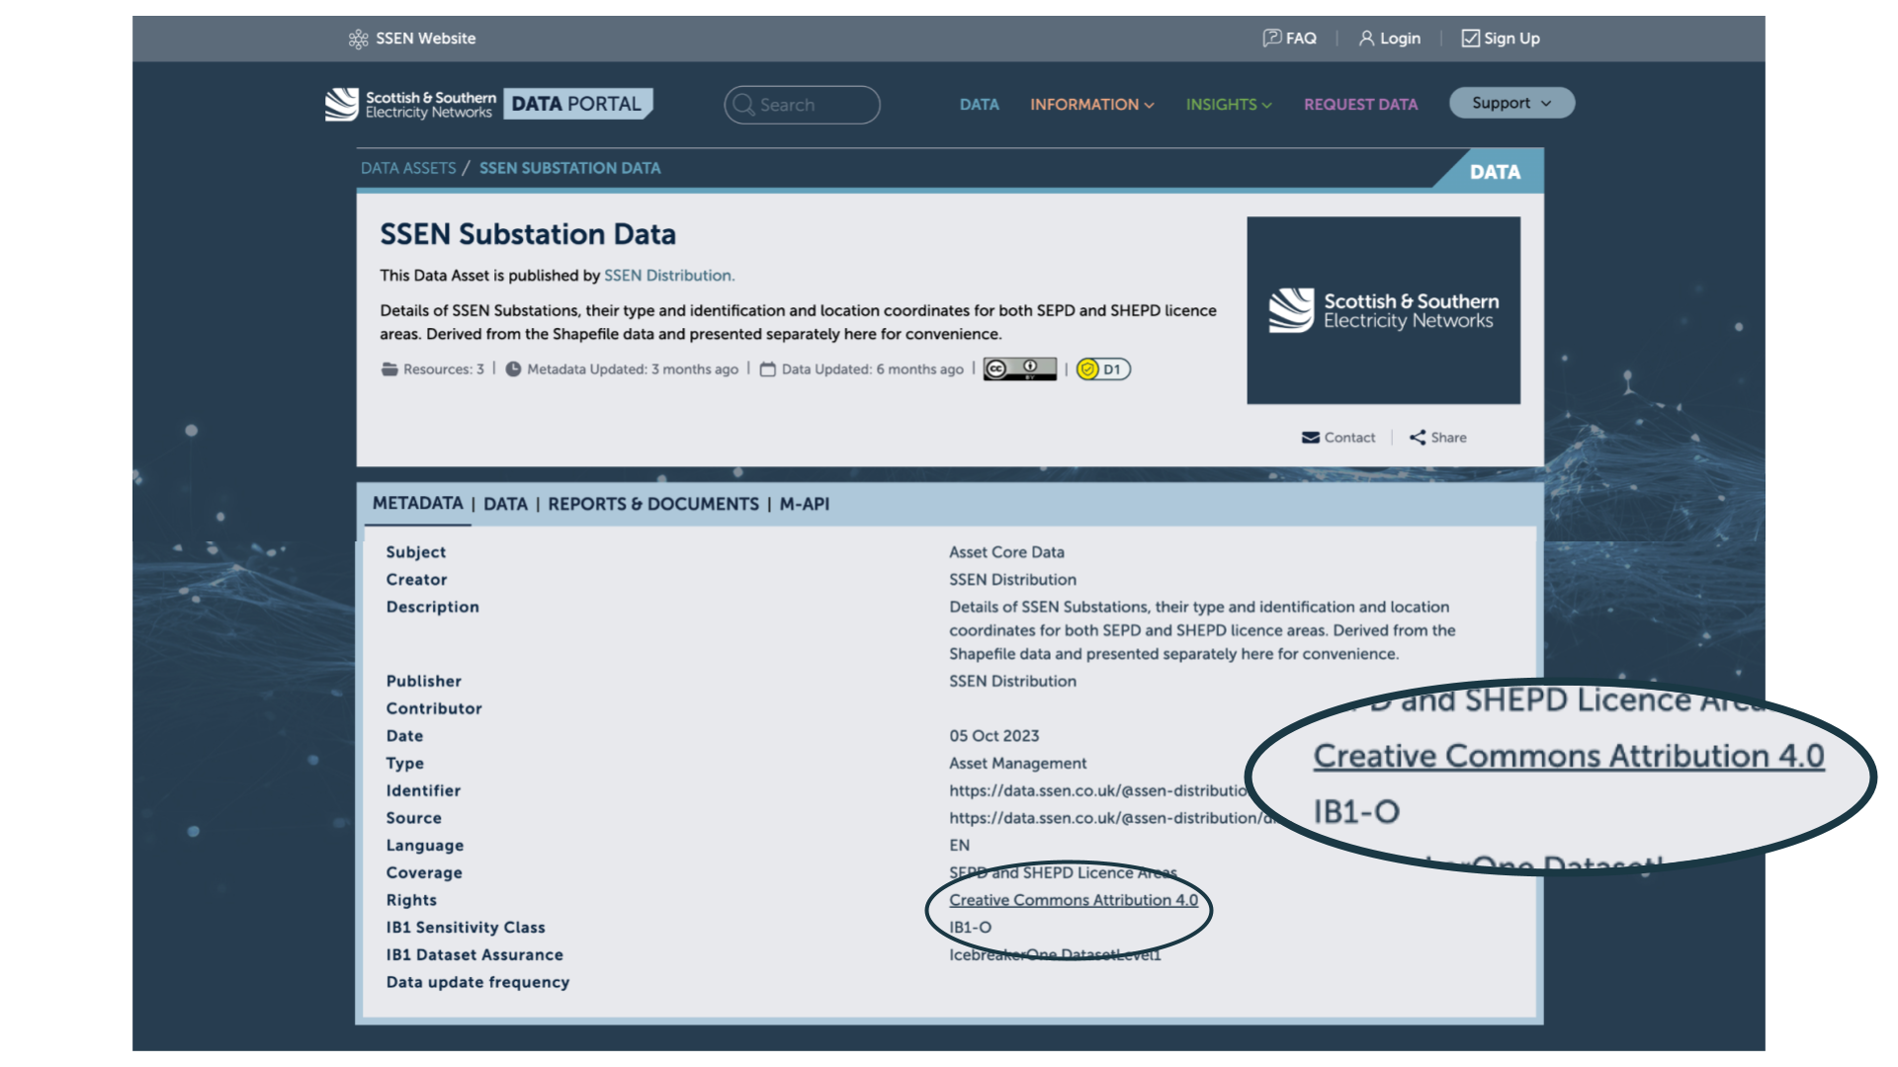

- Registration required
- Controlled by SSE terms and conditions & privacy policy
- Option to use SSO (Google, Github, LinkedIn, Microsoft)
- Additional opt-in to consent to contact for feedback on data use
- Open Data classification
- Open licence (CC-BY-4.0)

National Grid: Distribution Substations
https://connecteddata.nationalgrid.co.uk/dataset/distribution-substations
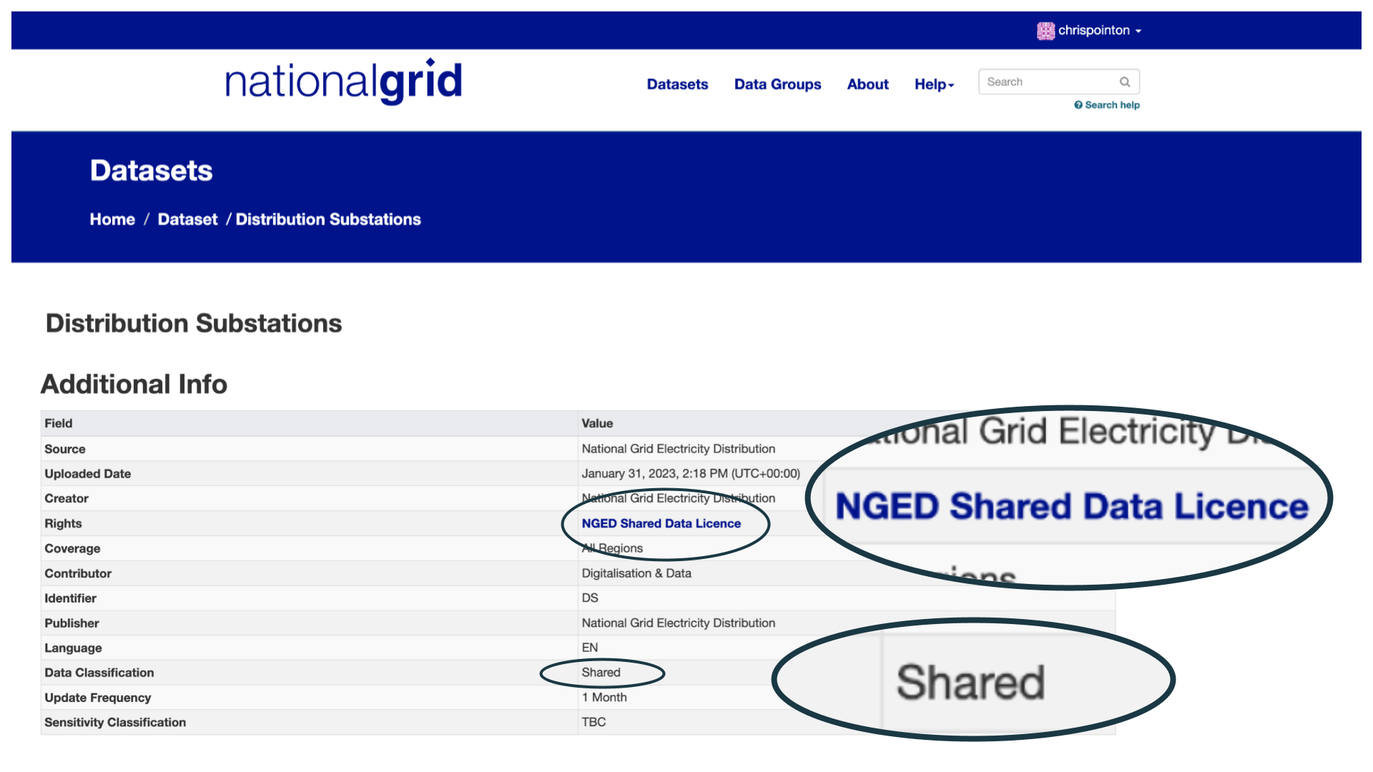
- Registration required
- Controlled by National Grid terms and conditions & privacy policy
- Shared Data classification
- Shared Licence

UKPN: Secondary Sites
https://ukpowernetworks.opendatasoft.com/explore/dataset/ukpn-secondary-sites/information/
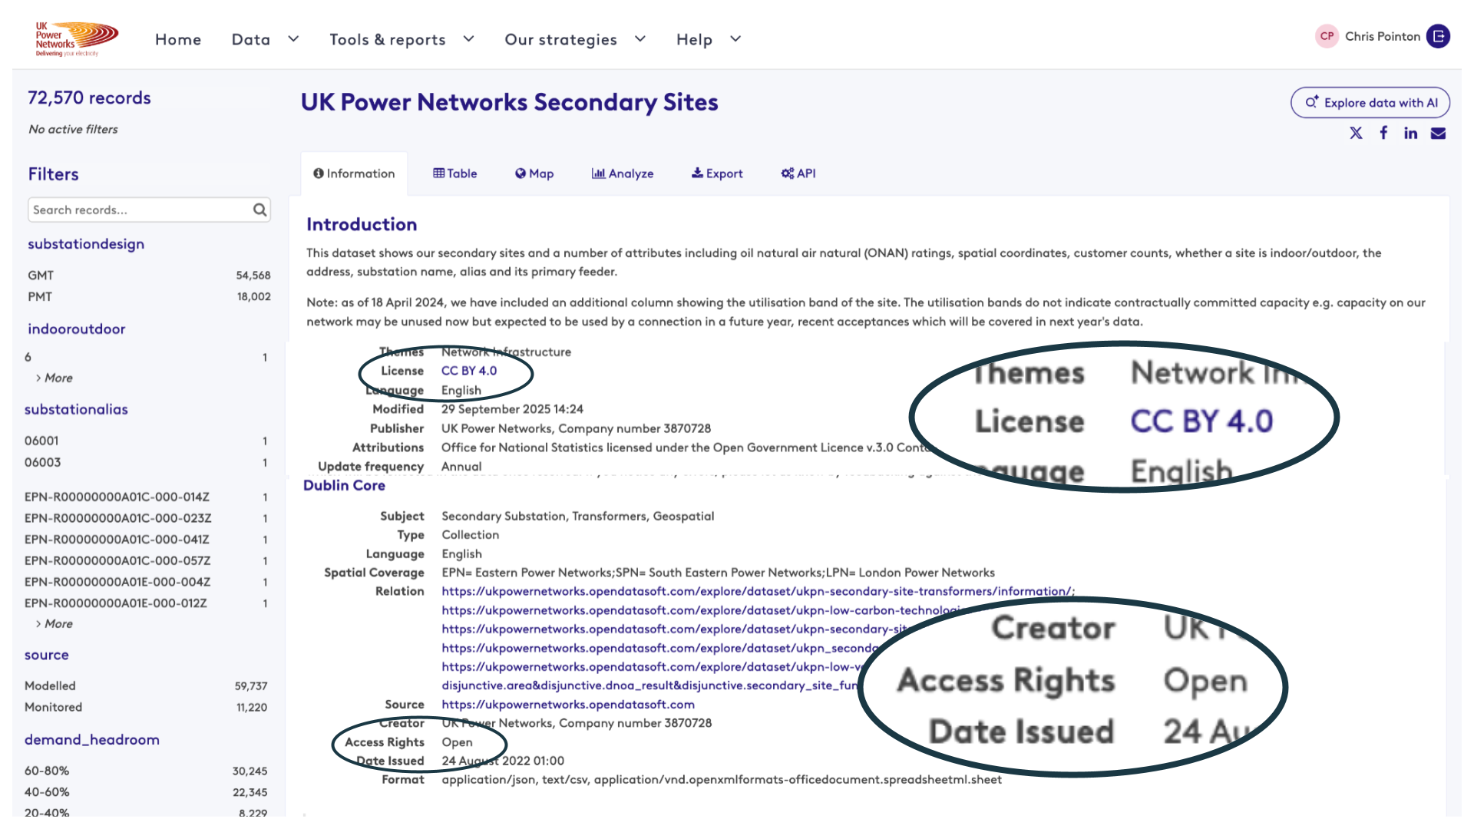
- Registration required (with Huwise - formerly Opendatasoft)
- Registration controlled by Huwise terms & conditions and privacy policy, with additional terms & conditions and privacy policy from UKPN
- Open Data classification (and Open Access rights)
- Open Licence (CC-BY-4.0)

SPEN LV Monitoring Aggregated Data & substation geopoints
https://spenergynetworks.opendatasoft.com/explore/dataset/lv_monitor/information/
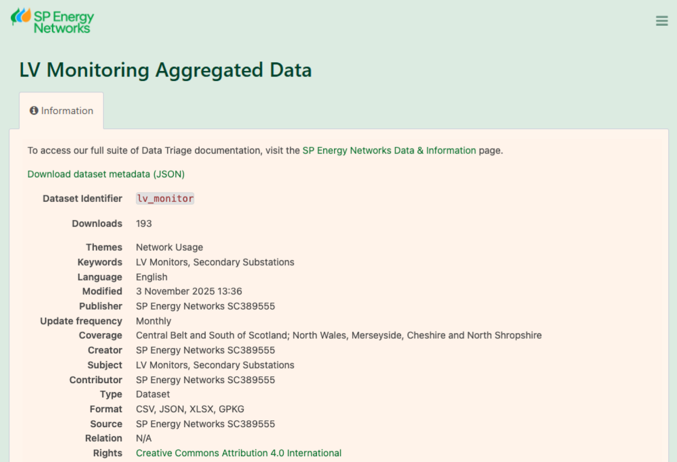

- Registration required (with Huwise - formerly Opendatasoft)
- Registration controlled by Huwise terms and conditions and privacy policy, with additional terms & conditions and privacy policy from SPEN
- Open Data classification (and Open Access rights)
- Open Licence (CC-BY-4.0)

Northern Power Grid Substation Sites List
https://northernpowergrid.opendatasoft.com/explore/dataset/substation_sites_list/information/
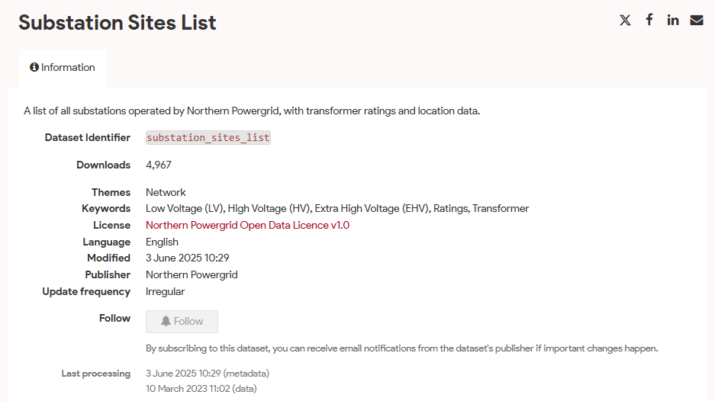

- Registration required (with Huwise - formerly Opendatasoft)
- Registration controlled by Huwise terms and conditions and privacy policy, with additional terms & conditions and privacy policy from NPG
- Open Data classification (and Open Access rights)
- Northern Power Grid Open Data License v1.0

ESTF Assured Open Data (AOD) scheme
The Energy Sector Trust Framework (ESTF) Assured Open Data (AOD) scheme is intended to provide assurance to users of energy sector Open Data. Once the publishing organisation has been verified as part of joining the ESTF, it executes the AOD scheme agreement, enabling it to make legally-binding assertions (assurance levels) about the legal, procedural, technical and social measures it applies when publishing and maintaining each dataset.

Recognising that many energy sector data publishers require registration, the base level of Open Data assurance (Level 1) contains the following clause:

D1.5.3 Anonymous downloads of open data is strongly preferred, but where the dataset requires compulsory registration before download:
D1.5.3.1 Registration is only conditional on completion of a lightweight challenge necessary for technical measures to minimise spam and bot abuse, such as verifying receipt of an email
D1.5.3.2 Acceptance of registration is automatic and immediate
D1.5.3.3 Registration may only be denied or withdrawn for misuse
D1.5.3.4 The registration process does not introduce any barriers to automated downloads or API access. Access to data is identical in all respects to a simple HTTP download of a published URL or API, except for the addition of a static credential or token that does not need renewing

Position of RIIO-2 licensees
RIIO-2 Licensee members of Open Energy will adopt the following approach to licensing and access control of Open Data, and recommend it to their fellow Licensees.

- Adopt and enact the Assured Open Data definition and purpose for registration described above
- Apply it to metadata and data, meaning either or both may require registration
- Classify data requiring this form of registration as Open
- Licence data requiring this form of registration with either CC-BY-4.0 or OGLv3
- Implement information on registration forms/access gating screens making clear the purpose of this form of registration to end users and work with other licensees to align this language
- As required for compliance with UK GDPR, ensure privacy policies correctly reflect the use and protection of registration data, the length of time the data will be held, the situations where it would be disclosed
- Ensure terms of service for data portals do not contradict the Open Data licence being asserted for datasets on the portals
- Provide information in the registration process and/or the dataset listings that clearly separates Open Data “lightweight” registration from Shared Data registration requirements where registration may be used for other purposes, including limitations on access or use of the data
- Use registration as an opportunity, on a strictly opt-in basis, to provide additional benefits to users such as subscription to dataset update notifications or notifications of training opportunities

Amendment to Assured Open Data
Open Energy will update the definition of Assured Open Data within the Energy Sector Trust Framework with the following additional clauses for Dataset Level 1 Assurance:

D1.5.3.5 Require additional opt-in consent to use registration data for any further purpose. Data access must not be made conditional on obtaining any additional consents (e.g. use of registration data for analytics).
D1.5.3.6 If registration is only available via a third party platform (Data Controller), the third party must also comply with conditions D1.5.3.1 - D 1.5.3.5.
D1.5.3.7 Third parties must transparently provide privacy policies and terms and conditions to the user if/where these differ from those of the Data Publisher.

